

**RRAP Technical Proposal**

**For HCE VCPCS v181**

**Release date:**  12/28/18

**Document ID:** RRAP Technical Proposal For HCE VCPCS v181 – M0

**Customer reference:** Mr. Kelvin CHUN

900 Metro Center Blvd

94404 Foster City, CA

UNITED STATES

**Date performed Start:** 12/26/18

**Date test performed at End:**  12/28/18

|  |
| --- |
| This document consists of 10 pages of which 0 are appendices. |

This page intentionally left blank.

Document History

Report version history and changes per version:

| Version | Date | Details | Author |
| --- | --- | --- | --- |
| M0 | 12/28/2018 | Creation | Simon CHEN |

Contents

1. Glossary 5

2. How does the RRAP work? 6

3. What Applus+ needs before starting to develop? 8

4. How does Applus+ verify RRAP method? 9

1. Glossary

|  |  |  |
| --- | --- | --- |
| Name | Definition | Owner |
| RRAP | Report Review Automation Program Tool developed to verify test reports | Applus |
| Test Tool | Tool developed by ICCSolutions (or similar) to execute test cases on the DUT and provide test report/s of the results for the test session. | ICCSolutions (or similar) |
| DUT | Device Under Test | HCE Developer |

1. How does the RRAP work?

The working method of RRAP for HCE VCPCS is shown as below:  
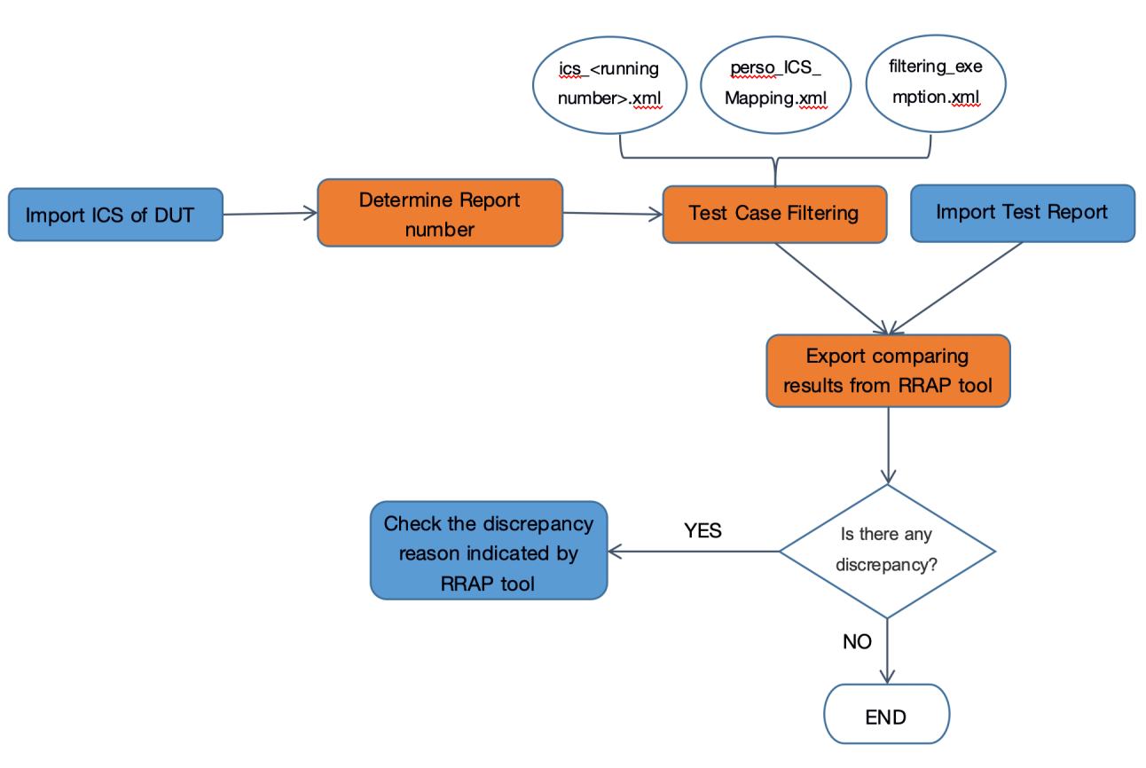

The orange part is done by RRAP which is developed by Applus+:

* **Determine Report number**: Based on three (3) special features[1] in ICS of product, the RRAP tool will determine how many reports are needed for this product and which feature configuration the product shall perform in each report.
* **Test Case Filtering:** is mainly consist of three steps:
* Compare ICS of product with each “ics_<running number>.xml”, and determine which ics profiles are SUPPORTED for this product.
* Look into “perso_ICS_Mapping.xml” to get relationship between ics profiles and test cases, filtering those test cases which are required to be tested for this product.
* Look into “filtering_exemption.xml” to exclude those test cases if the product supports corresponding features.
* **Export comparing results from RRAP tool:** In this step, RRAP tool will export an output file which may contain following information:
* Report number and product feature configuration
* List of ALL test cases for each report
* Test results generated from RRAP tool, for example: “PASS” if this test case needs to be tested, “NA” if this test case is not required for this product/report.
* Test results generated by Test Tool
* Comparison results: “True” if RRAP results and Test Tool results are the same, otherwise it will be “False”.

The blue part shows the operation that user (expected to be VISA employee) of RRAP tool needs to perform:

* **Import ICS of DUT & Import Test Report/s:** a simple user interface is shown below as a demo. It will be user-friendly and easy to understand.

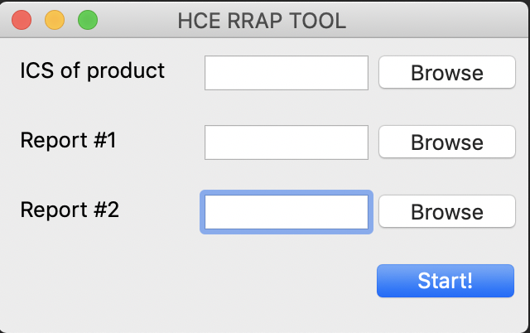

* **Check the discrepancy reason indicated by RRAP tool:** if there is a discrepancy between RRAP result and Test Tool result, it will be shown as well with the logic used by the RRAP to determine why the test case/s is/are applicable or not.

1. What Applus+ needs before starting to develop?
2. Structure of ICS of product based on VCPCS v181
   1. Preference: XML or JSON format*
3. Structure of Test Report which is generated by Test Tool
   1. Preference: XML or JSON format**

Note*: If it must be PDF format, the RRAP needs to be updated even when VISA does small changes in it.

For example:

ICS_June2018, the first field name is “Company Name”, if it changes to “1.Company Name”, the RRAP must to be updated in order to be able to reassign what ICS variable is related with such field.



Note**: Excel and word with tables can be accepted as second choice. Word and PDF are the worst formats doing the process slower and more complex.

1. How does Applus+ verify RRAP method?

Applus+ expects to use one file from ICCSolutions which contains: list of test cases and test cases filtering logic which is **INDEPENDANT** from RRAP logic.

The following shows an example of what kind of file we do expect to receive from ICCSolutions.



After receiving this file, Applus+ plans to verify RRAP method by following steps:

1. Generate 29 different ICS’s of product as emulation, each ICS’s of product will disable one feature among 29 features.
2. Generate 29 test results based on RRAP tool and ICS’s of emulated product.
3. Generate 29 test results based on the logic of ICCSolutions file and ICS’s of emulated product.
4. Compare output of item 2 and item 3 to check if there are discrepancies. If yes, report the issue and check if this is a Test Tool issue or RRAP issue.
5. Unless there is no discrepancy between RRAP result and Test Tool result, validation of RRAP is finished.

Note:

If ICCSolutions is not able to provide us such kind of file, Applus+ has in mind other ways to work around this validation in a similar way.

End of document.

1. More information described in Section 3.1 of document “*VCPCS Supplementary Technical Requirements for Test Tool Vendor v1.3”.*